Probability Worksheet

We are interested in the life expectancy of people in the United States (measured in years). We have Census data, so population notation will be used. The mean (µ) is 80 years and the standard deviation (σ) is 12.5 years for all of these problems.

- What is the probability of someone living between 80 and 100 years?

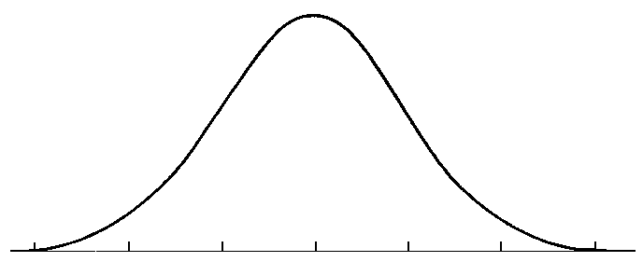

Step 1: Calculate Z-score
Preliminary Questions:
- Positive or negative?
- Between which two #s?

Z-score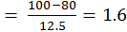

Step 2: Look up Z-score in Table B.1 (Column D)

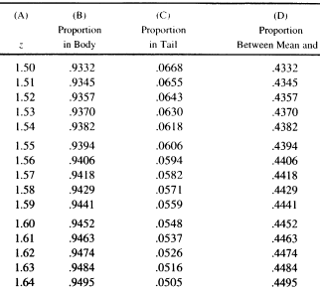

Step 3: Interpretation

The probability of an individual living between 80 to 100 years is 44.52%.

- What percent of people will live 100 or more years?

- What is the probability of living 100 years or less?

- What is the probability of someone living between 67 and 80 years?

- What percent of people will live 67 or more years?

- What percent of people will live less than 67 years?

- What is the probability of living between 70 and 95 years?

- What is the percent chance of living between 65 years and 75 years?

- What is the probability of living 40 years or less?

